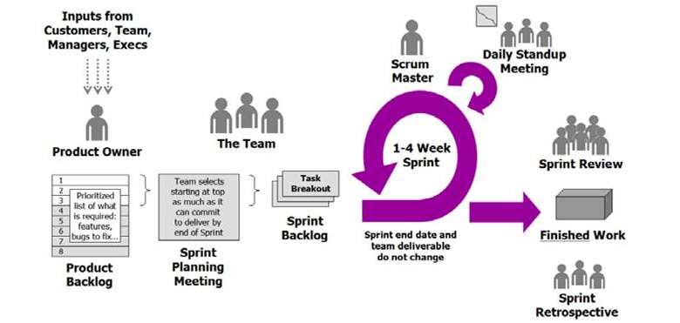

**Why choose Agile Scrum Methodology?**

Due to frequent change in requirement we work on Agile Scrum Methodology.

Its like an incremental model .In agile whole requirement of a software product divides according to

priorities. These priorities are saved in a list which is called product backlog.

**\*\*Product owner:**

In Agile process product owner will decide all the requirements for a software.

Product owner is a scrum development role for a person who represents the business or user

community and is responsible for working with the user group to determine what features will be in the product release.

**\*\*Product Backlog:**

All the user requirements are saved in product backlog. Product owner will decide which

wants user story's he/she to complete first. Then according to that , there will be a sprint meeting.

**\*\*3 Meetings:-**

**1. Sprint Meeting.**

**2. Daily Stand-Up Meeting.**

**3. Retrospective Meeting.**

**\*\*What is Sprint Meeting:-**

🡪In sprint meeting all the team member(developers, testers) will participate for each release of a product that is called sprint.

🡪In sprint meeting all the team members understand the modules and requirements and give their estimate for each task.

**\*\*Sprint:-**

🡪Sprint is of 1-2 weeks in which we complete 4-5 user stories according to software priorities.

**\*\*Scrum:-**

🡪Scrum is of multiple sprints in which we complete multiple user stories.

**\*\*Scrum Master:-**

🡪Scrum Master keeps the track of the Software Product.

🡪Scrum Master conduct a daily stand up meetings with all the team members everyday for 20-30 mins.

The scrum master asks the team members these three questions:

1. What did you do **yesterday?**

2. What will you do **today?**

3. Are there any a **impediments(defect in person's speech)** in your way?

**\*\*Sprint Backlogs:-**

🡪The sprint backlog is a list of tasks identified by the Scrum team to be completed during the Scrum sprint.

🡪During the sprint planning meeting, the team selects some number of product backlog items usually in the form of user stories, and identifies the tasks necessary to complete each user story.

🡪All the team members give their estimates how many hours will take to complete their tasks.

**\*\*Sprint Burndown Chart:-**

🡪The sprint burndown chart is a public displayed chart showing remaining work in the sprint backlog , Updated every day, it gives a simple view of the sprint progress.

**\*\*Retrospective meeting:-**

🡪After the release of each sprint all the team members discuss how the sprint was. How can we improve our product quality.

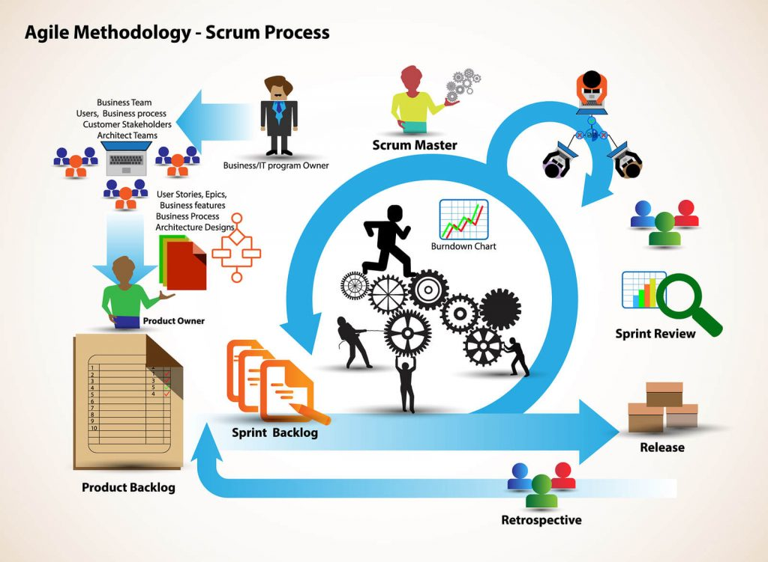

***Difference between findElement and findElements:-

|  |  |  |
| --- | --- | --- |
| **Sr.No** | **findElement** | **findElements** |
| **1** | Returns the first matching web element if multiple web elements are discovered by the locator. | Returns a list of multiple matching web elements. |
| **2** | Throws NoSuchElementException if the element is not found. | Returns an empty list if no matching element is found. |
| **3** | Detects a unique web element. | Returns a collection of matching elements. |

**\*\*\*\*\*domain :-**

🡪A domain name is the address where Internet users can access your website. A domain name is used for finding and identifying computers on the Internet. Computers use IP addresses, which are a series of number. However, it is difficult for humans to remember strings of numbers. Because of this, domain names were developed and used to identify entities on the Internet rather than using IP addresses.

🡪 A domain name is the identity of one or more IP addresses; for example, the domain name google.com points to the IP address "74.125.127.147". Domain names are invented as it is easy to remember a name rather than a long string of numbers. It would be easy to enter a domain name in the search bar than a long sequence of numbers.

***** **Query to find the second largest salary:-**

SELECT name, MAX(salary) AS salary FROM employee

WHERE salary < (SELECT MAX(salary) FROM employee

WHERE salary < (SELECT MAX(salary) FROM employee);

);